Flow-Oriented Modelling
Flow-oriented modeling is a software analysis technique that represents a system in terms of how data moves through the system.
It focuses on:
- Where data comes from
- Where data goes
- How data is processed
- Where data is stored
- How different processes communicate through data
The most commonly used technique for flow-oriented modeling is the Data Flow Diagram (DFD).

Simple idea
Input Data → Processing → Output Data
For example, in a college admission system:
Student details → Verify application → Store application → Admission confirmation

DFD
A Data Flow Diagram (DFD) is a graphical representation of the flow of data through a system.
A DFD answers questions such as:
- What data enters the system?
- What happens to the data?
- Where is the data stored?
- Who provides the data?
- Who receives the output?
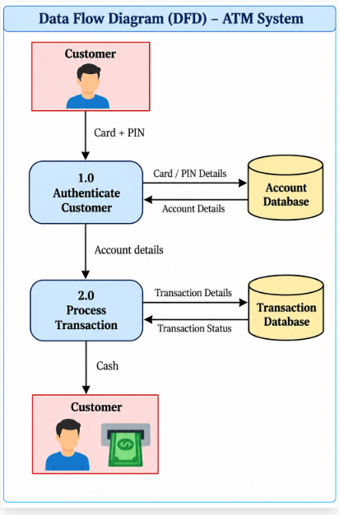

Main Components of DFD
A DFD generally contains four basic components.
Component | Meaning
External Entity | Source or destination of data
Process | Transforms input data into output
Data Flow | Movement of data
Data Store | Place where data is stored

1.External Entity
An external entity is a person, organization, device, or another system that sends or receives data from the system.
It is usually represented by a rectangle.
Example:
Student

Examples:
- Student
- Customer
- Bank
- Admin
- Teacher
- Supplier
- Government portal

Example
Student
|
| Application
↓
[Admission System]
Here, Student is an external entity.

2.Process
A process performs some operation on the incoming data.
It transforms input data into output data.
It is commonly represented using a circle/rounded rectangle depending on the DFD notation.
Example:
Process Payment

Input:
Payment Details
Output:
Payment Receipt
Therefore:
Payment Details
|
↓
| Student |
Process Payment
|
↓
Payment Receipt

3. Data Flow
A data flow represents the movement of data between:
- External entity and process
- Process and process
- Process and data store
- Data store and process
It is represented by an arrow.
Example:
Student
|
| Registration Form
↓
Register Student
The arrow indicates the direction of data movement.

4. Data Store

A data store represents a place where data is stored.
Examples:
- Database
- File
- Student records
- Employee database
- Product database
Example:
Student Database

A process may write data into or read data from the data store.
Student Data

Register Student

↓
Student DB

DFD Symbols
Standard symbols for DFDs are derived from the electric circuit diagram analysis and are shown in fig:
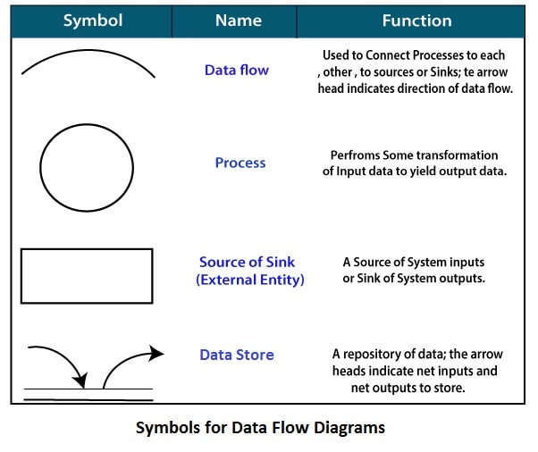
Circle: A circle (bubble) shows a process that transforms data inputs into data outputs.
Data Flow: A curved line shows the flow of data into or out of a process or data store.
Data Store: A set of parallel lines shows a place for the collection of data items. A data store indicates that the data is stored which can be used at a later stage or by the other processes in a different order. The data store can have an element or group of elements.
Source or Sink: Source or Sink is an external entity and acts as a source of system inputs or sink of system outputs.

Levels in Data Flow Diagrams (DFD)
The DFD may be used to perform a system or software at any level of abstraction. Infact, DFDs may be partitioned into levels that represent increasing information flow and functional detail. Levels in DFD are numbered 0, 1, 2 or beyond. Here, we will see primarily three levels in the data flow diagram, which are: 0-level DFD, 1-level DFD, and 2-level DFD.
0-level DFDM
A Context Diagram represents the entire system as one single process.
It shows:
- External entities
- Input data
- Output data
It does not show internal processes or databases in detail.

It is also known as fundamental system model, or context diagram represents the entire software requirement as a single bubble with input and output data denoted by incoming and outgoing arrows. Then the system is decomposed and described as a DFD with multiple bubbles. Parts of the system represented by each of these bubbles are then decomposed and documented as more and more detailed DFDs. This process may be repeated at as many levels as necessary until the program at hand is well understood. It is essential to preserve the number of inputs and outputs between levels, this concept is called leveling by DeMacro. Thus, if bubble "A" has two inputs x₁ and x₂ and one output y, then the expanded DFD, that represents "A" should have exactly two external inputs and one external output as shown in fig:
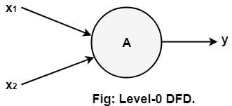

The Level-0 DFD, also called context diagram of the result management system is shown in fig. As the bubbles are decomposed into less and less abstract bubbles, the corresponding data flow may also be needed to be decomposed.

Example: Library Management System
Suppose we want to design a Library Management System.
External entities:
- Student
- Librarian
Inputs:
- Book request
- Return information
- Book information
Outputs:
- Book availability
- Issue confirmation
- Return confirmation

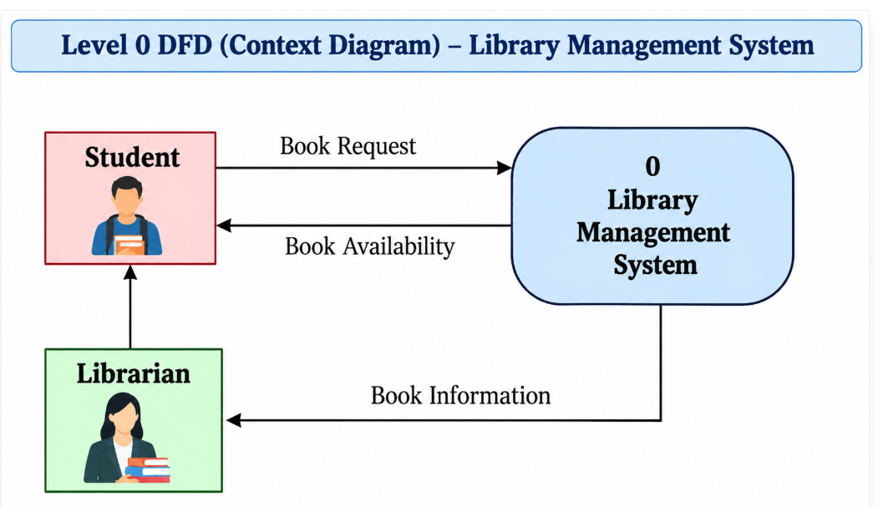

Level 0 DFD Student Result Management

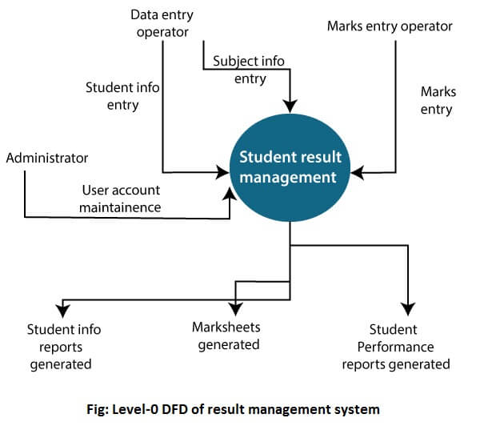
1-level DFD
Level 1 DFD decomposes the main system into major processes.
For a Library Management System, we can have:
- Manage Books
- Manage Members
- Issue Book
- Return Book

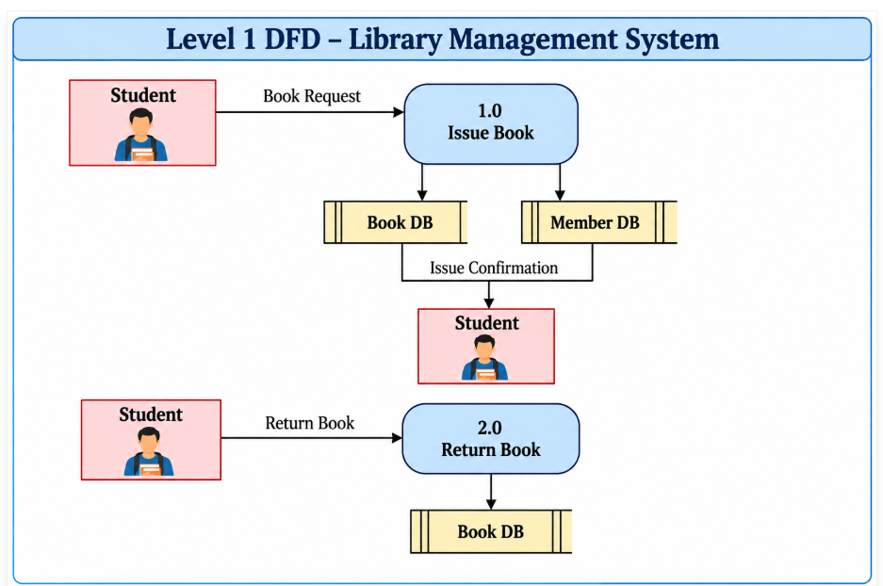
In 1-level DFD, a context diagram is decomposed into multiple bubbles/processes. In this level, we highlight the main objectives of the system and breakdown the high-level process of 0-level DFD into subprocesses.

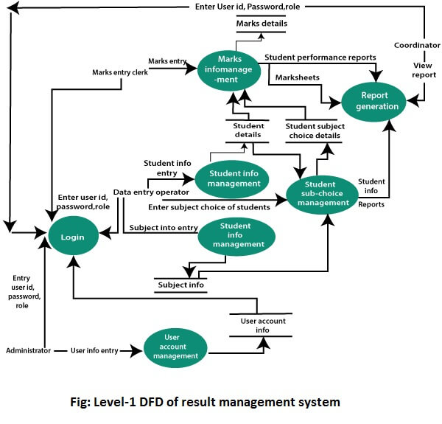

2-Level DFD
Level 2 DFD provides further detail about a particular process.
For example, the Issue Book process can be decomposed into:
- Check Member
- Check Book Availability
- Record Issue
- Generate Confirmation
2-level DFD goes one process deeper into parts of 1-level DFD. It can be used to project or record the specific/necessary detail about the system's functioning.

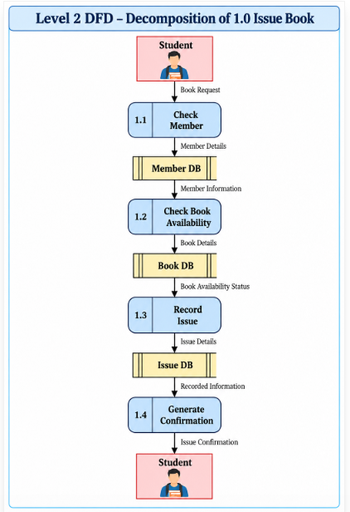
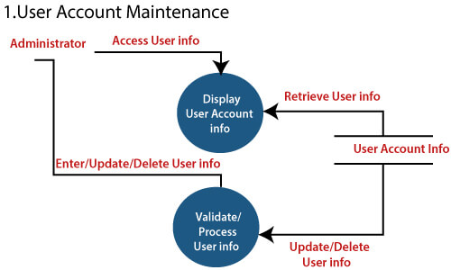

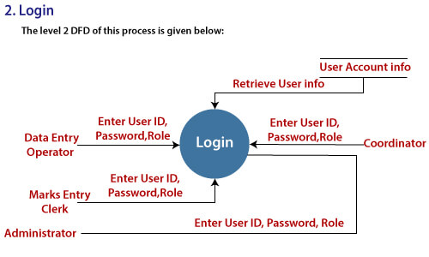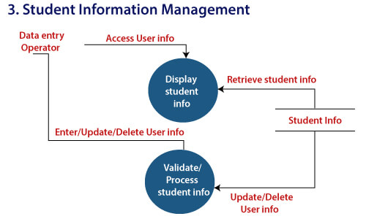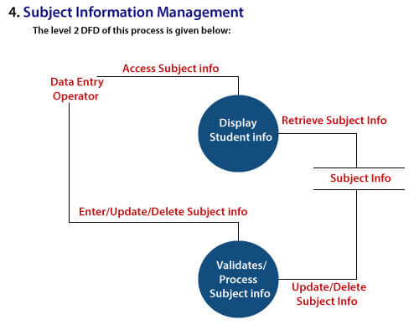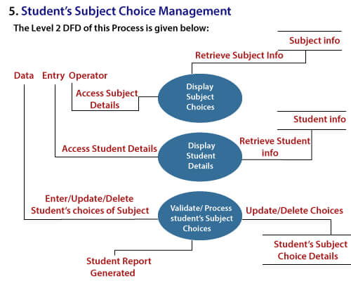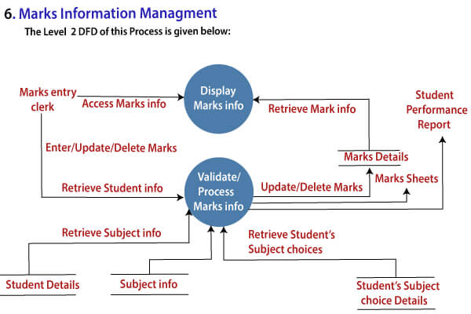

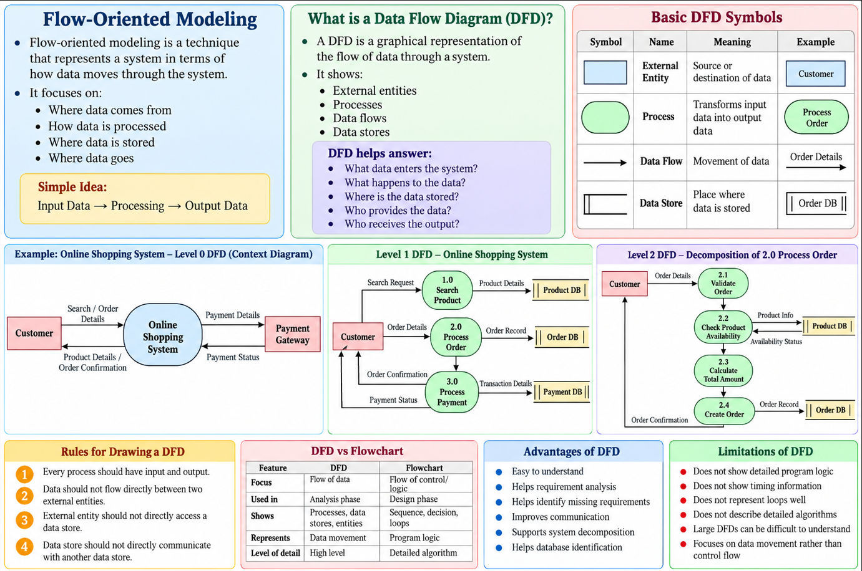

Coupling and Cohesion

Module Coupling
In software engineering, the coupling is the degree of interdependence between software modules. Two modules that are tightly coupled are strongly dependent on each other. However, two modules that are loosely coupled are not dependent on each other. Uncoupled modules have no interdependence at all within them.
The various types of coupling techniques are shown in fig:
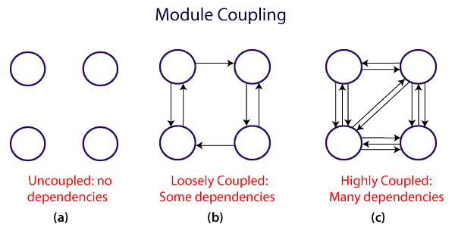
A good design is the one that has low coupling. Coupling is measured by the number of relations between the modules. That is, the coupling increases as the number of calls between modules increase or the amount of shared data is large. Thus, it can be said that a design with high coupling will have more errors.

Types of Module Coupling
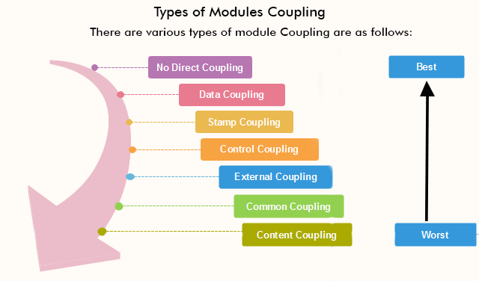

- No Direct Coupling: There is no direct coupling between M1 and M2.

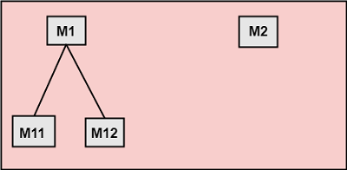
In this case, modules are subordinates to different modules. Therefore, no direct coupling.
2. Data Coupling: When data of one module is passed to another module, this is called data coupling.
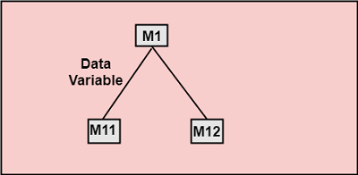

3. Stamp Coupling: Two modules are stamp coupled if they communicate using composite data items such as structure, objects, etc. When the module passes non-global data structure or entire structure to another module, they are said to be stamp coupled. For example, passing structure variable in C or object in C++ language to a module.
4. Control Coupling: Control Coupling exists among two modules if data from one module is used to direct the structure of instruction execution in another.
5. External Coupling: External Coupling arises when two modules share an externally imposed data format, communication protocols, or device interface. This is related to communication to external tools and devices.
6. Common Coupling: Two modules are common coupled if they share information through some global data items.
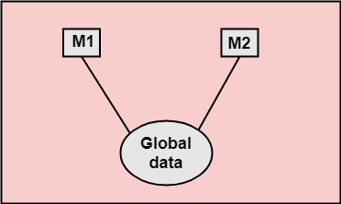

7. Content Coupling: Content Coupling exists among two modules if they share code, e.g., a branch from one module into another module.

Module Cohesion
In computer programming, cohesion defines to the degree to which the elements of a module belong together. Thus, cohesion measures the strength of relationships between pieces of functionality within a given module. For example, in highly cohesive systems, functionality is strongly related.
Cohesion is an ordinal type of measurement and is generally described as "high cohesion" or "low cohesion."
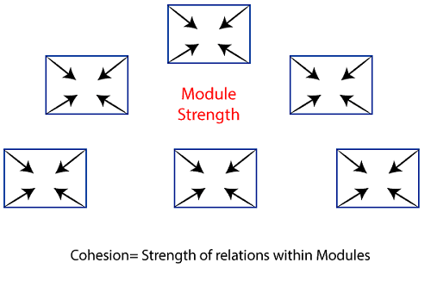

Types of Modules Cohesion
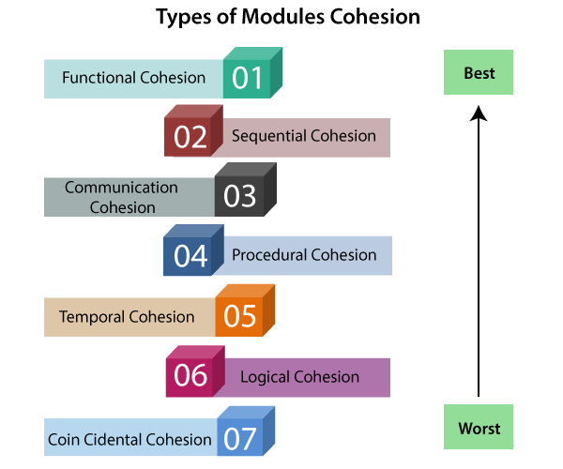
- Functional Cohesion: Functional Cohesion is said to exist if the different elements of a module, cooperate to achieve a single function.

- Sequential Cohesion: A module is said to possess sequential cohesion if the element of a module form the components of the sequence, where the output from one component of the sequence is input to the next.

- Communicational Cohesion: A module is said to have communicational cohesion, if all tasks of the module refer to or update the same data structure, e.g., the set of functions defined on an array or a stack.

- Procedural Cohesion: A module is said to be procedural cohesion if the set of purpose of the module are all parts of a procedure in which particular sequence of steps has to be carried out for achieving a goal, e.g., the algorithm for decoding a message.

- Temporal Cohesion: When a module includes functions that are associated by the fact that all the methods must be executed in the same time, the module is said to exhibit temporal cohesion.

- Logical Cohesion: A module is said to be logically cohesive if all the elements of the module perform a similar operation. For example Error handling, data input and data output, etc.

- Coincidental Cohesion: A module is said to have coincidental cohesion if it performs a set of tasks that are associated with each other very loosely, if at all.

Differentiate between Coupling and Cohesion
Coupling | Cohesion
Coupling is also called Inter-Module Binding. | Cohesion is also called Intra-Module Binding.
Coupling shows the relationships between modules. | Cohesion shows the relationship within the module.
Coupling shows the relative independence between the modules. | Cohesion shows the module's relative functional strength.
While creating, you should aim for low coupling, i.e., dependency among modules should be less. | While creating you should aim for high cohesion, i.e., a cohesive component/ module focuses on a single function (i.e., single-mindedness) with little interaction with other modules of the system.
In coupling, modules are linked to the other modules. | In cohesion, the module focuses on a single thing.

Function Oriented Design
Function Oriented design is a method to software design where the model is decomposed into a set of interacting units or modules where each unit or module has a clearly defined function. Thus, the system is designed from a functional viewpoint.

Design Notations
Design Notations are primarily meant to be used during the process of design and are used to represent design or design decisions. For a function-oriented design, the design can be represented graphically or mathematically by the following:
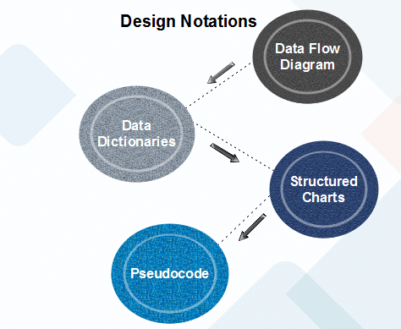

Data Flow Diagram
Data-flow design is concerned with designing a series of functional transformations that convert system inputs into the required outputs. The design is described as data-flow diagrams. These diagrams show how data flows through a system and how the output is derived from the input through a series of functional transformations.
Data-flow diagrams are a useful and intuitive way of describing a system. They are generally understandable without specialized training, notably if control information is excluded. They show end-to-end processing. That is the flow of processing from when data enters the system to where it leaves the system can be traced.
Data-flow design is an integral part of several design methods, and most CASE tools support data-flow diagram creation. Different ways may use different icons to represent data-flow diagram entities, but their meanings are similar.
The notation which is used is based on the following symbols:
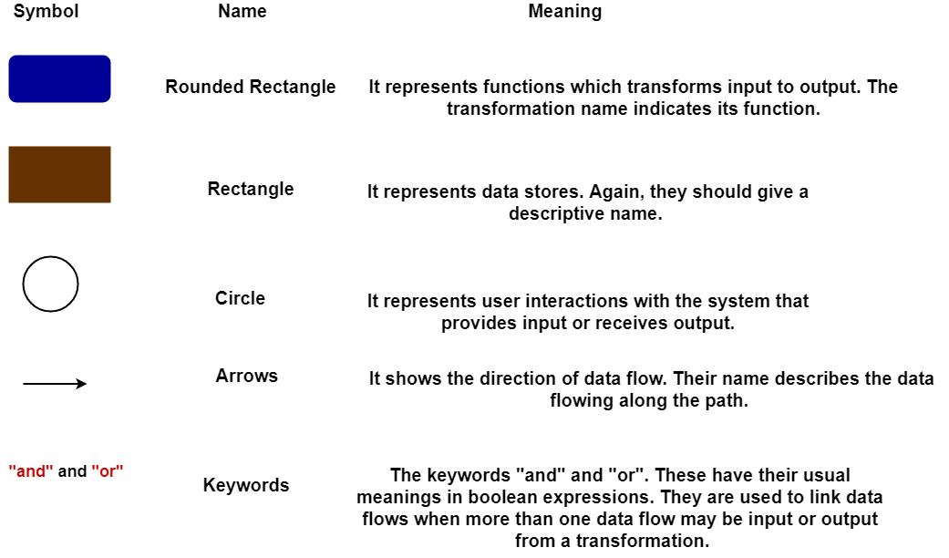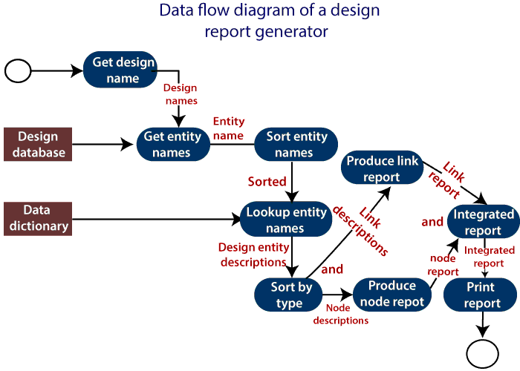
The report generator produces a report which describes all of the named entities in a data-flow diagram. The user inputs the name of the design represented by the diagram. The report generator then finds all the names used in the data-flow diagram. It looks up a data dictionary and retrieves information about each name. This is then collated into a report which is output by the system.

Data Dictionaries
A data dictionary lists all data elements appearing in the DFD model of a system. The data items listed contain all data flows and the contents of all data stores looking on the DFDs in the DFD model of a system.
A data dictionary lists the objective of all data items and the definition of all composite data elements in terms of their component data items. For example, a data dictionary entry may contain that the data grossPay consists of the parts regularPay and overtimePay.
grossPay = regularPay + overtimePay
For the smallest units of data elements, the data dictionary lists their name and their type.
A data dictionary plays a significant role in any software development process because of the following reasons:
- A Data dictionary provides a standard language for all relevant information for use by engineers working in a project. A consistent vocabulary for data items is essential since, in large projects, different engineers of the project tend to use different terms to refer to the same data, which unnecessarily causes confusion.
- The data dictionary provides the analyst with a means to determine the definition of various data structures in terms of their component elements.

Structured Charts
It partitions a system into block boxes. A Black box system that functionality is known to the user without the knowledge of internal design.
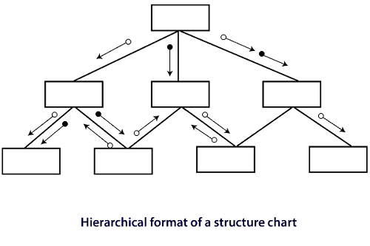

The image shows a Hierarchical Format of a Structure Chart used in software design and system development. A structure chart is a graphical representation that illustrates the hierarchical relationship between different components (modules or functions) of a system.

Key Elements of the Structure Chart:
- Rectangles (Modules):
  - Each rectangle represents a module, which can be a function, subroutine, or a system component.
  - The chart is organized in a hierarchy, with higher-level modules calling or interacting with lower-level modules.
- Arrows:
  - The arrows between modules show the direction of the flow of control or data between modules.
  - The direction of the arrow indicates that one module calls or interacts with another.
- Circles on the Arrows:
  - The circles (filled or unfilled) represent data being passed between modules. Filled circles could indicate control information, and unfilled circles might represent data flow.

Structured Chart is a graphical representation which shows:
- System partitions into modules
- Hierarchy of component modules
- The relation between processing modules
- Interaction between modules
- Information passed between modules
The following notations are used in structured chart:
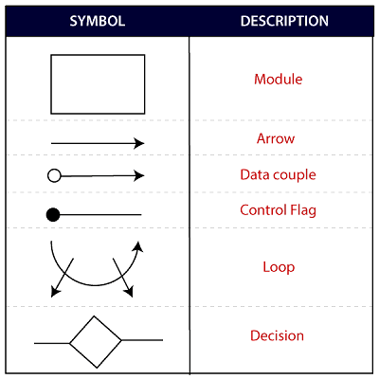

Pseudo-code
Pseudo-code notations can be used in both the preliminary and detailed design phases. Using pseudo-code, the designer describes system characteristics using short, concise, English Language phases that are structured by keywords such as If-Then-Else, While-Do, and End.

Object-Oriented Design
In the object-oriented design method, the system is viewed as a collection of objects (i.e., entities). The state is distributed among the objects, and each object handles its state data. For example, in a Library Automation Software, each library representative may be a separate object with its data and functions to operate on these data. The tasks defined for one purpose cannot refer or change data of other objects. Objects have their internal data which represent their state. Similar objects create a class. In other words, each object is a member of some class. Classes may inherit features from the superclass.
The different terms related to object design are:
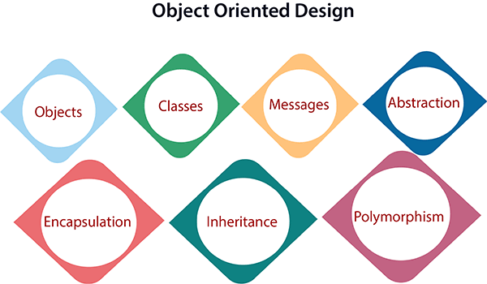
- Objects: All entities involved in the solution design are known as objects. For example, person, banks, company, and users are considered as objects. Every entity has some attributes associated with it and has some methods to perform on the attributes.
- Classes: A class is a generalized description of an object. An object is an instance of a class. A class defines all the attributes, which an object can have and methods, which represents the functionality of the object.
- Messages: Objects communicate by message passing. Messages consist of the integrity of the target object, the name of the requested operation, and any other action needed to perform the function. Messages are often implemented as procedure or function calls.
- Abstraction In object-oriented design, complexity is handled using abstraction. Abstraction is the removal of the irrelevant and the amplification of the essentials.
- Encapsulation: Encapsulation is also called an information hiding concept. The data and operations are linked to a single unit. Encapsulation not only bundles essential information of an object together but also restricts access to the data and methods from the outside world.
- Inheritance: OOD allows similar classes to stack up in a hierarchical manner where the lower or sub-classes can import, implement, and re-use allowed variables and functions from their immediate superclasses.This property of OOD is called an inheritance. This makes it easier to define a specific class and to create generalized classes from specific ones.
- Polymorphism: OOD languages provide a mechanism where methods performing similar tasks but vary in arguments, can be assigned the same name. This is known as polymorphism, which allows a single interface is performing functions for different types. Depending upon how the service is invoked, the respective portion of the code gets executed.

Structure Chart
Structure Chart represents the hierarchical structure of modules. It breaks down the entire system into the lowest functional modules and describes the functions and sub-functions of each module of a system in greater detail. This article focuses on discussing Structure Charts in detail.

What is a Structure Chart?
Structure Chart partitions the system into black boxes (functionality of the system is known to the users, but inner details are unknown).
- Inputs are given to the black boxes and appropriate outputs are generated.
- Modules at the top level are called modules at low level.
- Components are read from top to bottom and left to right.
- When a module calls another, it views the called module as a black box, passing the required parameters and receiving results.

Symbols in Structured Chart

1. Module
It represents the process or task of the system. It is of three types:
- Control Module: A control module branches to more than one submodule.
- Sub Module: Sub Module is a module which is the part (Child) of another module.
- Library Module: Library Module are reusable and invokable from any module.
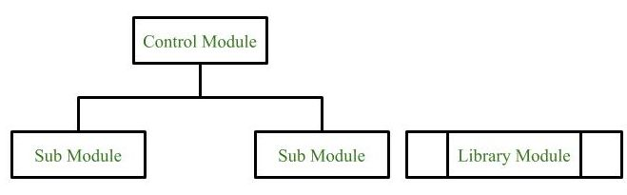

2. Conditional Call
It represents that control module can select any of the sub module on the basis of some condition
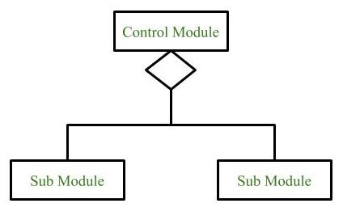

3. Loop (Repetitive call of module)
It represents the repetitive execution of module by the sub module. A curved arrow represents a loop in the module.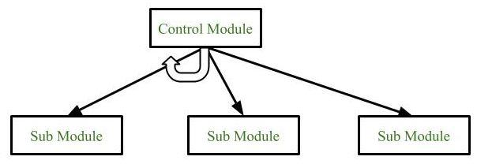
All the submodules cover by the loop repeat execution of module.

4. Data Flow
It represents the flow of data between the modules. It is represented by a directed arrow with an empty circle at the end.

.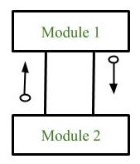
0

5. Control Flow
It represents the flow of control between the modules. It is represented by a directed with a filled circle at the end arrow

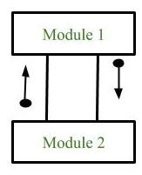
- Physical Storage

It is that where all the information are to be stored.
.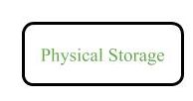

Example
Structure chart for an Email server
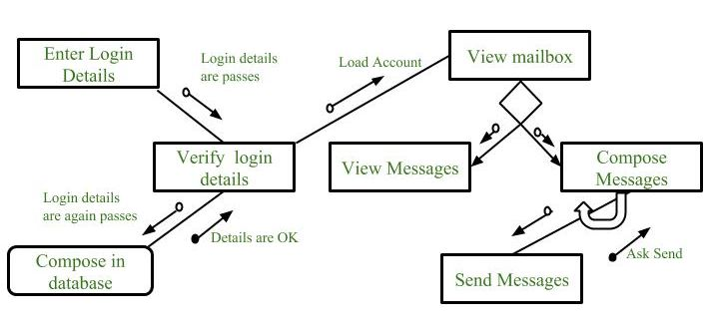

Types of Structure Chart
- Transform Centered Structure: These type of structure chart are designed for the systems that receives an input which is transformed by a sequence of operations being carried out by one module.
- Transaction Centered Structure: These structure describes a system that processes a number of different types of transaction.

Structured Design:

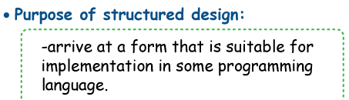

Structured Design
The Organized Plan is the product improvement stage after the Organized Examination. It entails developing a comprehensive and in-depth system design from the specifications gathered during the analysis phase. Organized Plan advances measured quality by separating the framework into more modest, sensible modules or subsystems. Ordered progression outlines, Control Stream Graphs (CFDs), and pseudocode are utilized to characterize module connections, points of interaction, and control stream. The essential objective of an Organized Plan is to create a plan that can be carried out and kept up with.

Key parts
i) Measured quality:
Definition: Particularity is the most common way of separating a bigger framework into more modest, reasonable modules or subsystems. The system is arranged hierarchically, and the purpose of each module is distinct.
Key components
Modules are independent units that perform particular and clear-cut capabilities. Pecking order: The position of modules in a progressive structure, with more elevated modules calling lower-level ones.
ii) Hierarchy Charts:
Definition: Hierarchy charts represent the hierarchical arrangement and relationships between various modules.
Key Components:
Module names are the names of specific modules.
Hierarchy Levels: Specify the level of each module in the hierarchy.
iii) Control Flow Diagrams (CFD):
Definition: Control Flow Diagrams show the flow of control or the sequence of operations within a module. They show how the processing steps are conducted.
Key Components:
Processes represent activities or tasks within a module.
Control Flows: Define the order in which processes are executed.
v) Pseudocode:
Pseudocode is a high-level explanation of the logic and functionality of a module. It is written algorithmically rather than using a specific programming language syntax.
Key Components:
Sequential statements describe steps that must be completed in a specific order.
Conditional statements represent decisions or branches of logic.
Looping statements describe recurring actions.
vi) Data Dictionary Updates:
Definition: The Data Dictionary is updated during the structured design phase to contain information about the data structures created for each module.
Key Components:
Updated data elements: Include any additions or changes to data items.
Data structure definitions: Include information about the newly created data structures.
vii) Review and validation:
Definition: The structured design artefacts are reviewed with stakeholders to ensure the design meets the specifications set during the structured analysis.
Key Components:
Feedback and Revisions: Any comments received are used to make necessary changes to the design.

Advantages of Structured Design
i) Modularity and maintenance:
Advantage: Separating the system into modular components improves maintainability. Each module may be developed, tested, and adjusted independently, making the system more manageable and updateable.
ii) Clarity and readability:
Advantage: Organized design tools like hierarchy charts, control flow diagrams, and pseudocode produce clear and understandable documentation. This clarity helps with both development and maintenance duties.
iii) Easy Debugging:
Advantage: Modularity and well-defined control flow make debugging easier. Issues inside a module can be isolated and resolved without affecting the overall system.
iv) Structured documentation:
Advantage: Structured design encourages the development of detailed documentation such as hierarchy charts, control flow diagrams, and pseudocode. This documentation is intended as a reference for developers and future maintainers.
v) Scalability:
Advantage: The modular nature of structured design facilitates scalability. New features or alterations can be implemented by adding or changing certain modules without affecting the entire system.
vi) Reusability:
Advantage: Well-defined modules can be utilized in other projects or system areas, saving time and effort.

Limitations of Structured Design:
i) Rigidity toward Change:
Limitation: The structured design may be stiff, making it less adaptive to changes in requirements. Modifications may necessitate changes to several modules, affecting the overall system.
ii) Complexity in large systems:
Limitation: In bigger systems, the dependency of modules and the complexity of control flows can make structured architecture difficult to manage and understand.
iii) Overemphasis on data flow
Limitation: Structured design may prioritize data flow and control above other considerations, such as user interfaces or external system interactions.
iv) Learning curve:
Limitation: There may be a learning curve for those unfamiliar with structured design techniques. Understanding and providing the required documents may necessitate extra training.
v) Not ideal for agile environments:
Limitation: Structured design is less appropriate for agile development approaches, emphasising flexibility and continuous adaptation to changing needs.
vi) Time-Consuming:
Limitation: Creating extensive documentation and following a disciplined design process can take time, particularly for smaller projects or those with frequently changing requirements.

Application
i) Software development includes:
Structured Design has been widely utilized in software system development, particularly when it was the dominant methodology. It proposed a systematic methodology for building and structuring software modules.
ii) Maintenance of legacy systems
Structured Design concepts are still used by organizations to maintain and update their existing systems. The structured approach makes it easier to comprehend and adapt legacy code.
iii) Big-Scale Systems:
Structured Design concepts can break down complexity into manageable modules in constructing large-scale systems that require modularity, maintainability, and a clear structure.
iv) Aerospace and Defense Systems:
Structured Design principles have long been employed in creating important systems such as aerospace and defence. The emphasis on clear organization and dependability is consistent with the needs of such systems.
v) Telecommunication systems:
Structured Design ideas can be used in telecommunications system design to construct modular and scalable structures that efficiently handle data and process flow.

Workflow
i) Receive Specifications:
Obtain the specifications developed during the Structured Analysis process. These requirements incorporate the analytical findings, such as Data Flow Diagrams (DFDs), data dictionaries, and process specifications.
ii) Identify modules:
Identify and define the modules according to the specifications. Modules are discrete units of functionality in the system.
iii) Create a Hierarchy Chart:
Create a hierarchy chart that shows the modules' organizational structure in a hierarchical order. This chart depicts the relationships and dependencies between modules.
iv) Refine the Control Flow:
Make control flow diagrams (CFDs) for each module. These diagrams depict the operational sequence and control flow within each module.
v) Please specify pseudocode:
Prepare pseudocode for each module. Pseudocode is a high-level explanation of a module's logic and functionality that is stated in an algorithmic style rather than following a specific programming language syntax.

Following are the differences between SA and SD
Aspect | Structural Analysis | Structural Design
Definition | -High-level software system structure. | - Individual components and modules are meticulously designed.
Focus | -System-level issues include components, modules, and their interactions. | - Component-level concerns specify how each system component will be implemented.
Scope | Encompasses the entire system. | Concentrates on individual modules or components.
Abstraction | High-level abstraction. | Abstraction levels range from low to medium.
Decisions | Major structural decisions include selecting the architectural style, patterns, and components. | Detailed decisions about algorithms, data structures, and code styles.
Purpose | Establishes the system's overall structure and behaviour while meeting high-level requirements | Converts the high-level architecture into detailed requirements for each component or module.
Artifacts | Architectural diagrams (such as UML diagrams) and architectural papers. | Detailed design documentation includes class diagrams, sequence diagrams, and so forth.
Example | Archi, Enterprise Architect. | Visual Studio, Eclipse, and Rational Rose

Software architecture:
Software architecture is the design and organization of a software system, including the structures, components, and interactions between them. It's the blueprint for a software system, and is analogous to the architecture of a building.
Software architecture is important because the decisions made at this stage can significantly impact the quality of the code, maintenance, deployment, and ease of development. These decisions are fundamental and costly to change once implemented.
Some key aspects of software architecture include:
- Structure: The fundamental abstractions, modules, and interfaces of the software
- Relationships: The interactions between components, and the data flow patterns
- Communication: The mechanism for communication between different parts of the system
- Principles: Guidelines to ensure the system meets its functional and non-functional requirements

Taxonomy of Architectural Styles

1] Data centered architectures:
- A data store will reside at the center of this architecture and is accessed frequently by the other components that update, add, delete, or modify the data present within the store.
- The figure illustrates a typical data-centered style. The client software accesses a central repository. Variations of this approach are used to transform the repository into a blackboard when data related to the client or data of interest for the client change the notifications to client software.
- This data-centered architecture will promote integrability. This means that the existing components can be changed and new client components can be added to the architecture without the permission or concern of other clients.
- Data can be passed among clients using the blackboard mechanism.
Advantages of Data centered architecture:
- Repository of data is independent of clients
- Client work independent of each other
- It may be simple to add additional clients.
- Modification can be very easy
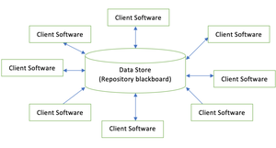
Data centered architecture

2] Data flow architectures:
- This kind of architecture is used when input data is transformed into output data through a series of computational manipulative components.
- The figure represents pipe-and-filter architecture since it uses both pipe and filter and it has a set of components called filters connected by lines.
- Pipes are used to transmitting data from one component to the next.
- Each filter will work independently and is designed to take data input of a certain form and produces data output to the next filter of a specified form. The filters don’t require any knowledge of the working of neighboring filters.
- If the data flow degenerates into a single line of transforms, then it is termed as batch sequential. This structure accepts the batch of data and then applies a series of sequential components to transform it.
Advantages of Data Flow architecture:
- It encourages upkeep, repurposing, and modification.
- With this design, concurrent execution is supported.
Disadvantage of Data Flow architecture:
- It frequently degenerates to batch sequential system
- Data flow architecture does not allow applications that require greater user engagement.
- It is not easy to coordinate two different but related streams
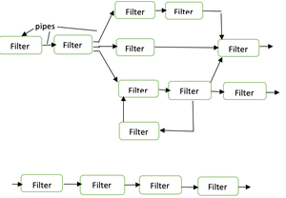
Data Flow architecture

3] Call and Return architectures
It is used to create a program that is easy to scale and modify. Many sub-styles exist within this category. Two of them are explained below.
- Remote procedure call architecture: This components is used to present in a main program or sub program architecture distributed among multiple computers on a network.
- Main program or Subprogram architectures: The main program structure decomposes into number of subprograms or function into a control hierarchy. Main program contains number of subprograms that can invoke other components.
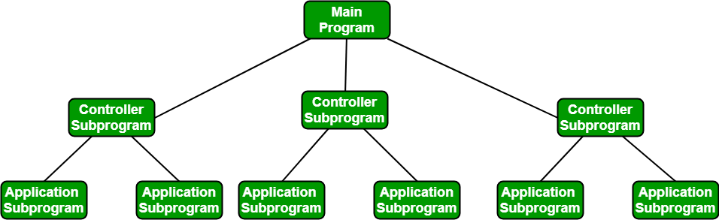

4] Object Oriented architecture
The components of a system encapsulate data and the operations that must be applied to manipulate the data. The coordination and communication between the components are established via the message passing.
Characteristics of Object Oriented architecture:
- Object protect the system’s integrity.
- An object is unaware of the depiction of other items.
Advantage of Object Oriented architecture:
- It enables the designer to separate a challenge into a collection of autonomous objects.
- Other objects are aware of the implementation details of the object, allowing changes to be made without having an impact on other objects.

5] Layered architecture
- A number of different layers are defined with each layer performing a well-defined set of operations. Each layer will do some operations that becomes closer to machine instruction set progressively.
- At the outer layer, components will receive the user interface operations and at the inner layers, components will perform the operating system interfacing(communication and coordination with OS)
- Intermediate layers to utility services and application software functions.
- One common example of this architectural style is OSI-ISO (Open Systems Interconnection-International Organisation for Standardisation) communication system.
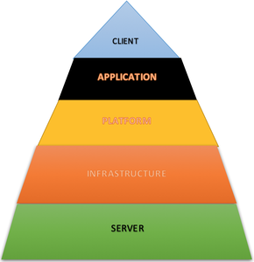
Layered architecture

COMPONENT LEVEL DESIGN :
Component level design is the definition and design of components and modules after the architectural design phase. Component-level design defines the data structures, algorithms, interface characteristics, and communication mechanisms allocated to each component for the system development.

A complete set of software components is defined during architectural design. But the internal data structures and processing details of each component are not represented at a level of abstraction that is close to code. Component-level design defines the data structures, algorithms, interface characteristics, and communication mechanisms allocated to each component.

Video snapshot need to keep

An individual software component is a software package, a web
service, a web resource, or a module that encapsulates a set of
related functions (or data). All system processes are placed into
separate components so that all of the data and functions inside each
component are semantically related (just as with the contents of
classes). Because of this principle, it is often said that components
are modular and cohesive. With regard to system-wide co-ordination,
components communicate with each other via interfaces. When a
component offers services to the rest of the system, it adopts
a provided interface that specifies the services that other components
can utilize, and how they can do so. This interfac

Designing Traditional Components:

An individual software component is a software package, a web service, a web resource, or a module that encapsulates a set of related functions (or data). All system processes are placed into separate components so that all of the data and functions inside each component are semantically related (just as with the contents of classes). Because of this principle, it is often said that components are modular and cohesive. With regard to system-wide co-ordination, components communicate with each other via interfaces. When a component offers services to the rest of the system, it adopts a provided interface that specifies the services that other components can utilize, and how they can do so. This interface. This interface can be seen as a signature of the component - the client does not need to know about the inner workings of the component (implementation) in order to make use of it. This principle results in components referred to as encapsulated. The UML illustrations within this article represent provided interfaces by a lollipop-symbol attached to the outer edge of the component.

